**16 BIT ADDITION**

**EXPERIMENT 5**

**AIM:** To write an assembly language program to implement 16-bit addition using 8085 processor.

**ALGORITHM:**

1. Load the lower part of the first number in the B register.
2. Load the lower part of the second number in A (accumulator).
3. Add both the numbers and store.
4. Load the higher part of the first number in the B register.
5. Load the higher part of the second number in A (accumulator).
6. Add both the numbers with carrying from the lower bytes (if any) and store them at the next location.

**PROGRAM:**

LHLD 2500

XCHG

LHLD 2502

DAD D

SHLD 2504

HLT

**INPUT:**

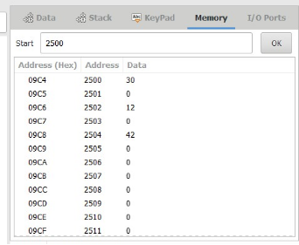

**OUTPUT:**

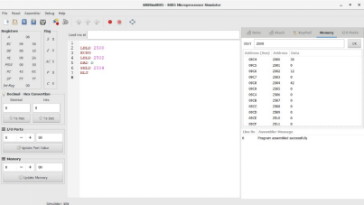

**RESULT:** Thus the program was executed successfully using 8085 processor simulator.